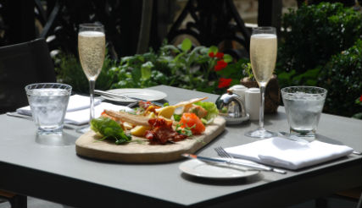
SUMMER TERRACE MENU
All served with Dressed Garden Salad,
Coleslaw and Minted New Potatoes
Native Lobster Half £32.00
Whole £60.00
Dressed Dorset Crab £18.00
Yorkshire Chicken Supreme £18.00
Hampshire Chalk Stream Trout £18.00
Dorset Goats Cheese & Broccoli Tart (V, G/F) £18.00
Club Special
Half Lobster, Dressed Crab, Smoked Salmon,
Prawns Marie Rose £65.00
Indulgence
West Sussex Strawberries & Vanilla Cream £7.90
West Sussex Raspberries & Vanilla Cream £7.90

